Department of Computer Science and Engineering
Premier University, Chattogram
CSE 1116: Object Oriented Programming Laboratory (OOPL)
OOP Lab Project Proposal

Student Name: | Pranta Mohajan  Shreya Sen  Arpita Paul | Student ID: | 0222510005101025  0222510005101029  0222510005101033
Section: | A | Session: | 2026
Course Title: | Object Oriented Programming Laboratory
Course Code | CSE 1116 | CLO | CLO4

1. Project Title
Online Food Delivery Rider System

2. Project Description / Scenario

This project simulates a real-time backend dispatch system for an online food delivery platform that automatically assigns delivery riders to incoming customer orders. The architecture follows a 3-level class hierarchy (Person Rider BikeRider CycleRider), where polymorphic methods calculate delivery duration dynamically based on vehicle-specific constraints (e.g., speed, fuel, and load capacity).

Utilizing the Assignable interface, the system assigns tasks uniformly across rider types. If all riders are occupied during order placement, a custom NoRiderAvailableException handles the failure gracefully. The core backend leverages a HashMap <String, Rider> for O(1) fast rider lookups and an ArrayList <Order> to maintain order logs, all managed interactively through an admin Java Swing GUI.

3. Objectives
• OOP Architecture: Implement a multilevel inheritance hierarchy (Person Rider BikeRider / CycleRider) using strict encapsulation to manage common and vehicle-specific rider attributes.
• Dynamic Order Assignment: Build automated dispatch logic to assign incoming customer orders to eligible riders based on real-time availability and vehicle parameters.
• Polymorphic Estimation: Utilize method overriding to calculate travel time dynamically for BikeRider and CycleRider, along with method overloading for flexible rider search.
• Robust Error Handling: Formulate a custom checked (NoRider Available Exception) to handle peak-demand assignment bottlenecks gracefully.
• Interactive Dispatch Interface: Construct a Java Swing GUI backed by an ArrayList <Order> and HashMap <String, Rider> to manage rider records, process active orders, and monitor real-time delivery states.

4. Functional Requirements (Major Features)
Code | Description
FR1 | Register a new rider (Bike Rider or Cycle Rider) with name, ID, phone number, and vehicle-specific attribute.
FR2 | Display the list of all registered riders along with real-time availability status (Available / On Delivery).
FR3 | Create a new delivery order with customer name, restaurant name, and delivery address.
FR4 | Automatically search and assign the first available matching rider to a new order; throw a No Rider Available Exception and show an error dialog if no rider is free.
FR5 | Mark an in-progress order as Delivered, which frees the assigned rider and updates their availability status.
FR6 | View the complete order history / rider-assignment log, showing each order's status (Pending / Assigned / Delivered).

5. Proposed Classes and Their Responsibilities
Class/Interface Name | Type/Role | Key Attributes | Key Responsibilities / Methods
Person | Abstract Parent Class | name, id, phone | Declares abstract method getRoleDescription(); provides common getters/setters for personal information.
Assignable | Interface | — | Declares operational contract with assignOrder(Order o) and completeOrder() methods.
Rider | Abstract Child Class (implements Assignable) | vehicleType, isAvailable, rating, currentOrder | Implements interface methods assignOrder() and completeOrder(); defines abstract method calculateDeliveryTime().
BikeRider | GrandChild Class (Subclass of Rider) | fuelLevel, maxDistanceKm | Extends Rider; overrides calculateDeliveryTime() based on motorbike speed and getRoleDescription().
CycleRider | GrandChild Class (Subclass of Rider) | maxLoadKg | Extends Rider; overrides calculateDeliveryTime() based on bicycle speed and getRoleDescription().
Order | Regular Class | orderId, customerName, restaurant, address, status | Encapsulates order data; provides getters, setters, and toString() for log/GUI representation.
NoRiderAvailableException | Custom Exception Class | message | Extends Exception; models runtime assignment failures when all riders are busy.
DeliveryManager | Collections-based Class | orderList (ArrayList<Order>), riderMap (HashMap<String, Rider>) | Manages centralized dispatch operations: addRider(), addOrder(), assignRider(), completeOrder(), and overloaded searchRider().
RiderAssignmentGUI | GUI Class (extends JFrame) | GUI components (JTable, JButton, JTextField) | Bridges user interactions to DeliveryManager methods; visualizes live rider/order tables and error dialogs.

6. UML Class Diagram
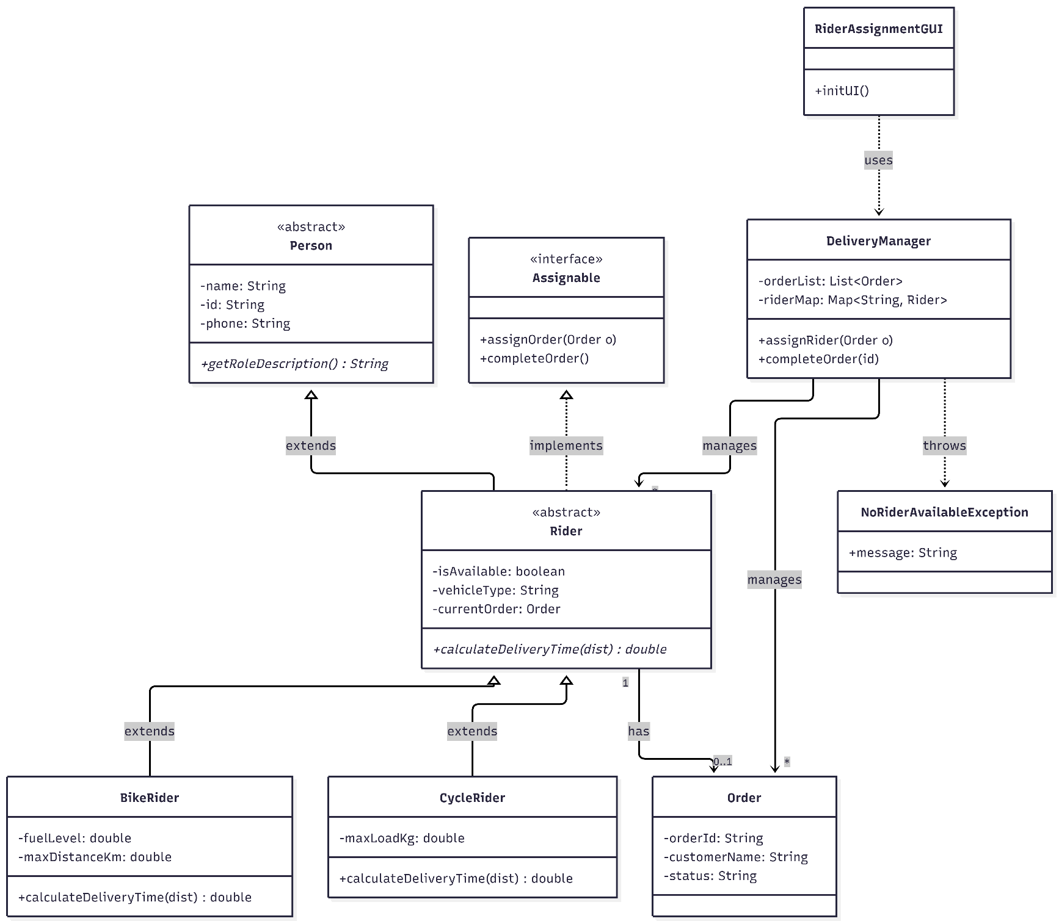

7. Application of OOP Concepts
Concept | Where / How Applied in Your Design
Encapsulation | All fields in Person, Rider, BikeRider, CycleRider, and Order are private, exposed only through public getters/setters; DeliveryManager keeps its ArrayList and HashMap private, accessed only via its own methods.
Inheritance | Three-level hierarchy Person → Rider → BikeRider / CycleRider. BikeRider and CycleRider inherit name/id/phone/status logic from Person and Rider and add their own vehicle-specific attributes.
Polymorphism | calculateDeliveryTime() and displayInfo() are overridden differently in BikeRider and CycleRider; DeliveryManager.assignOrder() calls rider.calculateDeliveryTime() polymorphically without knowing the concrete subtype. Overloaded searchRider(String id) vs searchRider(String vehicleType) demonstrates method overloading.
Abstraction | Person is declared abstract with an abstract method getRoleDescription(), hiding how each rider type describes itself. The Assignable interface exposes assignOrder()/completeOrder() to DeliveryManager without exposing rider-internal state.

8. Timeline
Phase | Planned Dates | Key Task(s) | Deliverable / Milestone
Phase 1: Proposal & Design | Aug 4 – Aug 9, 2026 | Finalize scenario, class list, and UML diagram. | Approved Proposal
Phase 2: Core Class Implementation | Aug 18 – Aug 23, 2026 | Implement Person/Rider/BikeRider/CycleRider hierarchy, encapsulation, constructors. | Core classes compiling
Phase 3: Interfaces & Exception Handling | Aug 23 – Aug 30, 2026 | Implement the Assignable interface, polymorphic methods, and NoRiderAvailableException. | Interface + exception working
Phase 4: Collections & GUI Development | Aug 2 – Sep 5, 2026 | Integrate ArrayList/HashMap in DeliveryManager and build the Swing GUI. | Functional GUI prototype
Phase 5: Testing & Debugging | Sep 6 – Sep 12, 2026 | Test all required scenarios, including exception handling and edge cases. | Test report
Phase 6: Report Writing & Submission | Sep 13 – Sep 18, 2026 | Write the Final Report, take screenshots, and submit all deliverables. | Final submission

9. Knowledge Profile (KP) Mapping
K1 Natural Sciences
Applies to Your Project? ☐ Yes ☐ Partially ☒ No
How / Justification: Not applicable — this is a pure software/dispatch-logic project; no natural-science principle is modeled.
K2 Mathematics
Applies to Your Project? ☐ Yes ☒ Partially ☐ No
How / Justification: Simple numeric computation is used in calculateDeliveryTime() and fee estimation (distance/speed based).
K3 Engineering Fundamentals
Applies to Your Project? ☒ Yes ☐ Partially ☐ No
How / Justification: The entire design rests on core OOP fundamentals: classes, objects, encapsulation, and control-flow logic for rider/order matching.
K4 Specialist Engineering Knowledge
Applies to Your Project? ☒ Yes ☐ Partially ☐ No
How / Justification: Uses multilevel inheritance, polymorphism, a custom interface, exception handling, and the Collections Framework — the course's specialist techniques.
K5 Engineering Design
Applies to Your Project? ☒ Yes ☐ Partially ☐ No
How / Justification: Deliberate design choices: a three-level hierarchy vs a flat design, HashMap for rider lookup vs ArrayList-only search, and GUI layout for dispatcher workflow.
K6 Engineering Practice
Applies to Your Project? ☒ Yes ☐ Partially ☐ No
How / Justification: Use of a Java IDE, Git version control, consistent naming conventions, and manual test cases for each feature.
K7 Engineering and Society
Applies to Your Project? ☐ Yes ☐ Partially ☒ No
How / Justification: NoRiderAvailableException protects the dispatcher from an unsafe double-assignment, reflecting responsible behaviour toward real users (customers and riders).
K8 Research Literature
Applies to Your Project? ☐ Yes ☒ Partially ☐ No
How / Justification: Consulted Oracle's official Java Collections Framework tutorial and Swing/JFrame documentation beyond the lecture notes.

10. Complex Engineering Problem (CEP) Mapping
P1 Depth of Knowledge Required
Addressed? ☒ Yes ☐ Partially ☐ Not Applicable
How / Justification: Requires integrating inheritance, polymorphism, exception handling, and Collections together — e.g. assignRider() polymorphically calls calculateDeliveryTime() and then updates the HashMap — rather than using each concept in isolation.
P2 Range of Conflicting Requirements
Addressed? ☒ Yes ☐ Partially ☐ Not Applicable
How / Justification: Trade-off between a flexible 3-level hierarchy (BikeRider/CycleRider) vs a simpler flat Rider class, and between GUI usability (auto-refreshing tables) vs limited development time.
P3 Depth of Analysis Required
Addressed? ☒ Yes ☐ Partially ☐ Not Applicable
How / Justification: Weighed HashMap vs ArrayList-only storage for riders, and whether vehicle type should be a simple enum field or separate subclasses, before settling on subclassing to practise polymorphism.
P4 Familiarity of Issues
Addressed? ☒ Yes ☐ Partially ☐ Not Applicable
How / Justification: The custom exception models the “all riders busy at order time” failure — a state-based real-world condition, not the standard textbook example.
P5 Extent of Applicable Codes
Addressed? ☐ Yes ☐ Partially ☒ Not Applicable
How / Justification: No formal safety-critical codes of practice apply at this project scale; no external regulatory standard was voluntarily followed beyond good coding conventions.
P6 Extent of Stakeholder Involvement
Addressed? ☐ Yes ☐ Partially ☒Not Applicable
How / Justification: The GUI serves a single dispatcher/admin role; no separate rider-facing or customer-facing interface is implemented, so stakeholder diversity is limited.
P7 Interdependence
Addressed? ☒ Yes ☐ Partially ☐ Not Applicable
How / Justification: The Rider hierarchy, Assignable interface, custom exception, Collections in DeliveryManager, and the GUI all depend on each other — a change in Rider's availability field must be reflected in the HashMap and immediately re-rendered in the GUI table.

11. Complex Engineering Activity (CEA) Mapping
A1 Range of Resources
Addressed? ☒ Yes ☐ Partially ☐ Not Applicable
How / Justification: Used the IDE, Java API/Swing documentation, and instructor consultation/peer discussion during design and debugging.
A2 Level of Interaction
Addressed? ☒ Yes ☐ Partially ☐ Not Applicable
How / Justification: Resolved the interaction between how Rider's inheritance hierarchy stores state (isAvailable) and how the GUI table needs to refresh to reflect that state after every assignment.
A3 Innovation
Addressed? ☒ Yes Partially ☐ Not Applicable
How / Justification: Choosing a HashMap keyed by rider ID (rather than an ArrayList-only search) for quick lookup was an original design decision, not copied from a lab example.
A4 Consequences for Society and the Environment
Addressed? ☐ Yes ☐ Partially ☒ Not Applicable
How / Justification: Limited real-world consequence at this project scale; the only related consideration is validating input to avoid assigning an order to an unavailable rider.
A5 Familiarity
Addressed? ☒ Yes ☐ Partially ☐ Not Applicable
How / Justification: Building a multi-panel Swing GUI with live table updates driven by a HashMap-backed backend goes beyond the single-class examples directly demonstrated in class labs.

Instructor Review
Decision: ☐ Approved ☐ Revisions Required ☐ Not Approved

Instructor Comments:

Student Signature: ______________________________ Date: ____________

Instructor Signature: ____________________________ Date: ____________

